Networking Lab 4

Virtual Network Peering

Lab Overview

This lab covers how to enable connectivity between two virtual networks. Each virtual network is an isolated environment until we allow communication. Here, we will see how to configure vnet peering to enable communication between two virtual networks. Virtual network peering is supported within and across regions. In this lab, we will create peering between two virtual networks, verify route updates and reachability between the peered networks.

Lab Diagram

Check connectivity between virtual networks

So far you have configured two virtual networks from labs 1 and 3. Let’s try to reach virtual machines across the two peers.

1. From the Azure portal, go to the **Virtual machines** page.
2. Note the Public IP of VM **vnet1-vm-mgmt1**.
3. Note the public IP of VM **vnet-hub-vm1**.
4. Connect to virtual machine vnet1-vm-mgmt1 using its public IP.

ssh <username>@<Public_IP_of_VM>

1. Ping private IP of virtual machine vnet-hub-vm1.
2. Connect to VM vnet1-vm-mgmt1. From this VM try to do SSH to vm vnet-hub-vm1.
3. Did the connection succeed? Why?

Peer virtual networks

1. In the Search box at the top of the Azure portal, begin typing *vnet1*. When **vnet1** appears in the search results, select it.
2. Go to **Settings** 🡪 **Peerings**, and then select **+ Add**, as shown in the following picture:

E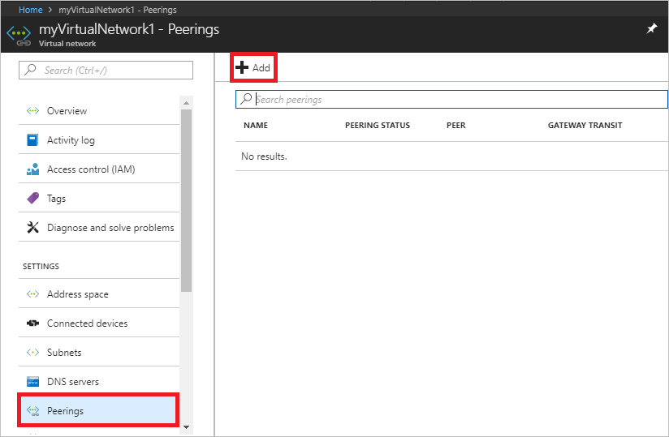

1. Enter, or select, the following information, accept the defaults for the remaining settings, and then select **OK**.

|  |  |
| --- | --- |
| **Setting** | **Value** |
| Name of the peering from vne1 to remote virtual network | peer-vnet1-to-vnet-hub |
| Subscription | Select your subscription. |
| Virtual network | Select 'vnet-hub' from the list. |
| Name of the peering from vnet-hub to vnet1 | peer-Vnet-hub-to-vnet1 |
| Allow forwarded traffic from vnet1 to vnet-hub | Enabled |
| Allow forwarded traffic from vnet-hub to vnet1 | Enabled |

Verify the peering status. This should show as Connected.

Now verify the routes in vnet1.

Go to the virtual machine vnet1-vm-mgmt1 page and go to Settings 🡪 Networking tab.

Click on the network interface name. See the screenshot below to find the network interface name.

The route table should show a route added to the table for network 10.0.0.0/16. The next hop type for this route shows Vnet peering.

Verify reachability between the peered vnets:

Let’s try to reach virtual machines across the two peers.

1. From the Azure portal, go to the **Virtual machines** page.
2. Note the Public IP of VM **vnet-hub-vm1**.
3. Note the private IP of VM **vnet1-vm-web1.**
4. Connect to virtual machine vnet-hub-vm1using its public IP.

ssh <username>@<Public_IP_of_VM>

1. Ping the vnet-hub virtual machine vnet-hub-vm1 from vnet1.

*ping 10.0.1.4*

1. Is the ping successful?
2. Which rule was used? Verify the nsg rules.